Karan Bharaj (T00693289). Assignment 3- COMP 2231

Question 1

To answer the question, the methods push(), pop(), peek(), isEmpty(), size(), toString() in LinkedListStack.java (using java.util.LinkedList) were executed in the driver (as shown below):

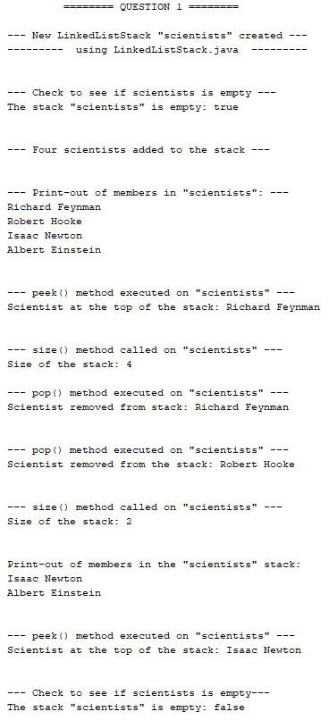

* New LinkedListStack() called “scientists” created
* isEmpty() method checked on stack “scientists” when empty
* Push() method called four times to add four scientist names to the stack
* toString() method call to return the members of the stack (topmost element is the last name entered)

* Peek() method called to return topmost name in the stack
* Size() method called to return number of members in the stack
* Pop() method called to remove topmost member
* Pop() method called again to remove topmost member
* Size() method called to return number of members in the stack

* toString() method call to return the members of the stack

* Peek() method called to return topmost name in the stack
* isEmpty() method checked on stack “scientists” when not empty
* 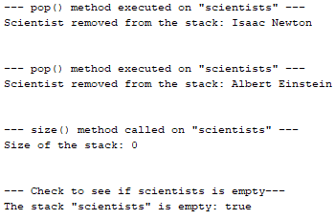Pop() method called again to remove topmost member
* Pop() method called again to remove topmost member
* Size() method called to return number of members in the stack

* isEmpty() method checked on stack when empty again

Question 2

To answer the question, the methods push(), pop(), peek(), isEmpty(), size(), toString() in ArrayListStack.java (using java.util.ArrayList) were executed in the driver (as shown below):

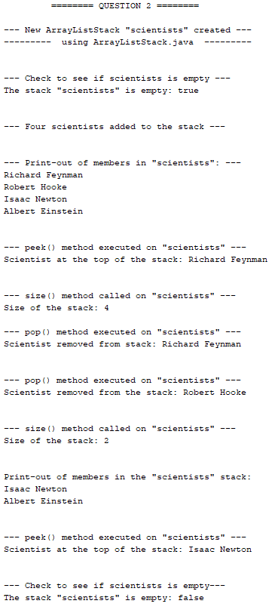

* New ArrayListStack() called “scientists” created
* isEmpty() method checked on stack “scientists” when empty
* Push() method called four times to add four scientist names to the stack
* toString() method call to return the members of the stack (topmost element is the last name entered)

* Peek() method called to return topmost name in the stack
* Size() method called to return number of members in the stack
* Pop() method called to remove topmost member

* Pop() method called again to remove topmost member
* Size() method called to return number of members in the stack

* toString() method call to return the members of the stack
* Peek() method called to return topmost name in the stack
* isEmpty() method checked on stack “scientists” when not empty
* 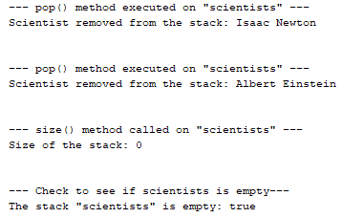Pop() method called again to remove topmost member
* Pop() method called again to remove topmost member
* Size() method called to return number of members in the stack

* isEmpty() method checked on stack when empty again

Question 3

To answer the question, the methods enqueue(), dequeue(), first(), isEmpty(), size(), toString() in LinkedListQueue.java (using java.util.LinkedList) were executed in the driver (as shown below):

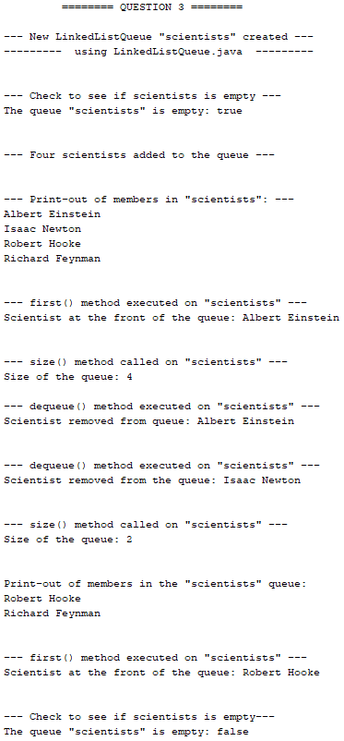

* New LinkedListQueue() called “scientists” created
* IsEmpty() method checked on the queue “scientists” when empty
* Enqueue() method called four times to add four names to the queue
* toString() method call to show the members of the queue (topmost element is the front of the queue)
* First() method called to return frontmost member of the queue
* Size() method called to return number of members in the queue
* Dequeue() method called to remove frontmost member

* Dequeue () method called again to remove frontmost member
* Size() method called to return number of members in the queue

* toString() method call to return the members of the queue
* First() method called to return frontmost name in the queue
* isEmpty() method checked on queue “scientists” when not empty
* 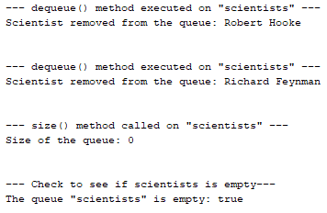Dequeue() method called again to remove frontmost member

* Dequeue() method called again to remove frontmost member
* Size() method called to return number of members in the queue

* isEmpty() method checked on queue when empty again

Question 4

To answer the question, the methods enqueue(), dequeue(), first(), isEmpty(), size(), toString() in ArrayListQueue.java (using java.util.ArrayList) were executed in the driver (as shown below):

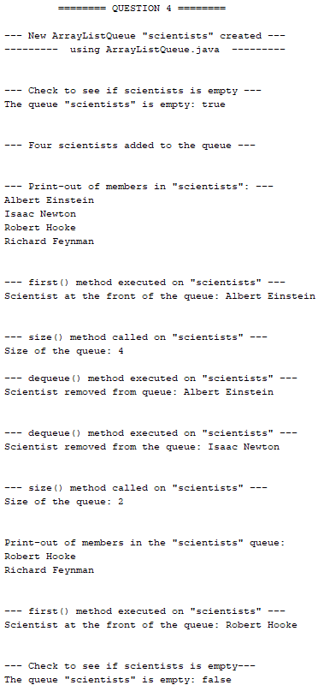

* New ArrayListQueue() called “scientists” created
* IsEmpty() method checked on the queue “scientists” when empty
* Enqueue() method called four times to add four names to the queue
* toString() method call to show the members of the queue (topmost element is the front of the queue)
* First() method called to return frontmost member of the queue

* Size() method called to return number of members in the queue
* Dequeue() method called to remove frontmost member
* Dequeue () method called again to remove frontmost member
* Size() method called to return number of members in the queue

* toString() method call to return the members of the queue
* First() method called to return frontmost name in the queue
* isEmpty() method checked on queue “scientists” when not empty
* 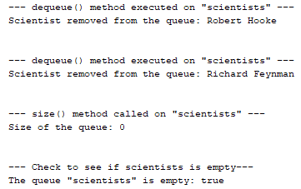Dequeue() method called again to remove frontmost member
* Dequeue() method called again to remove frontmost member
* Size() method called to return number of members in the queue

* isEmpty() method checked on queue when empty again